**Experiment 5**

**Q1) Write a program to swap 2 numbers.**

**Code:**

#!/bin/bash

read -p "enter the first number a=" a

read -p "enter the second number b=" b

temp=`expr $a`

a=`expr $b`

b=`expr $temp`

echo "a=" $a

echo "b=" $b

**Output:**

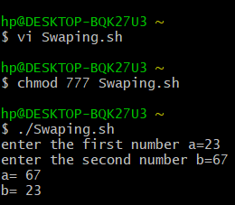

**Q2) Write a script to add some text in already existing file.**

**Code:**

#!/bin/bash

echo "The contents of the file are:"

cat MyFile

echo " "

echo "Add new contents to the file:"

cat >> MyFile

**Output:**

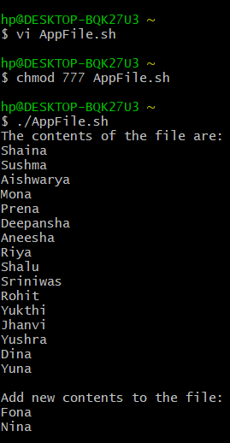

**Q3) Write a script to demonstrate use of arithmetic operator.**

**Code:**

#!/bin/bash

read -p "enter the first number: " a;

read -p "enter the second number: " b;

c=`expr $a + $b`

d=`expr $a - $b`

e=`expr $a "*" $b`

f=`expr $a / $b`

g=`expr $a % $b`

echo "a + b =" $c

echo "a - b =" $d

echo "a "*" b =" $e

echo "a / b =" $f

echo "a % b =" $g

**Output:**

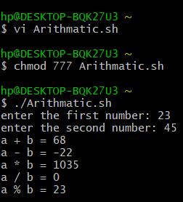

**Q4) Write a script to delete file.**

**Code:**

#!/bin/bash

echo "Enter the name of the file to be deleted:"

read fname

rm $fname

**Output:**

